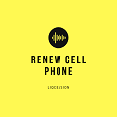

**Renew Cellar iPhone Grading Descriptions**

***For Used iPhone All Series****--****Grade A+, A, AB, B***

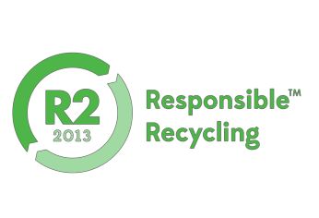



***All devices are fully tested and fully functional***

* **100% Power up**

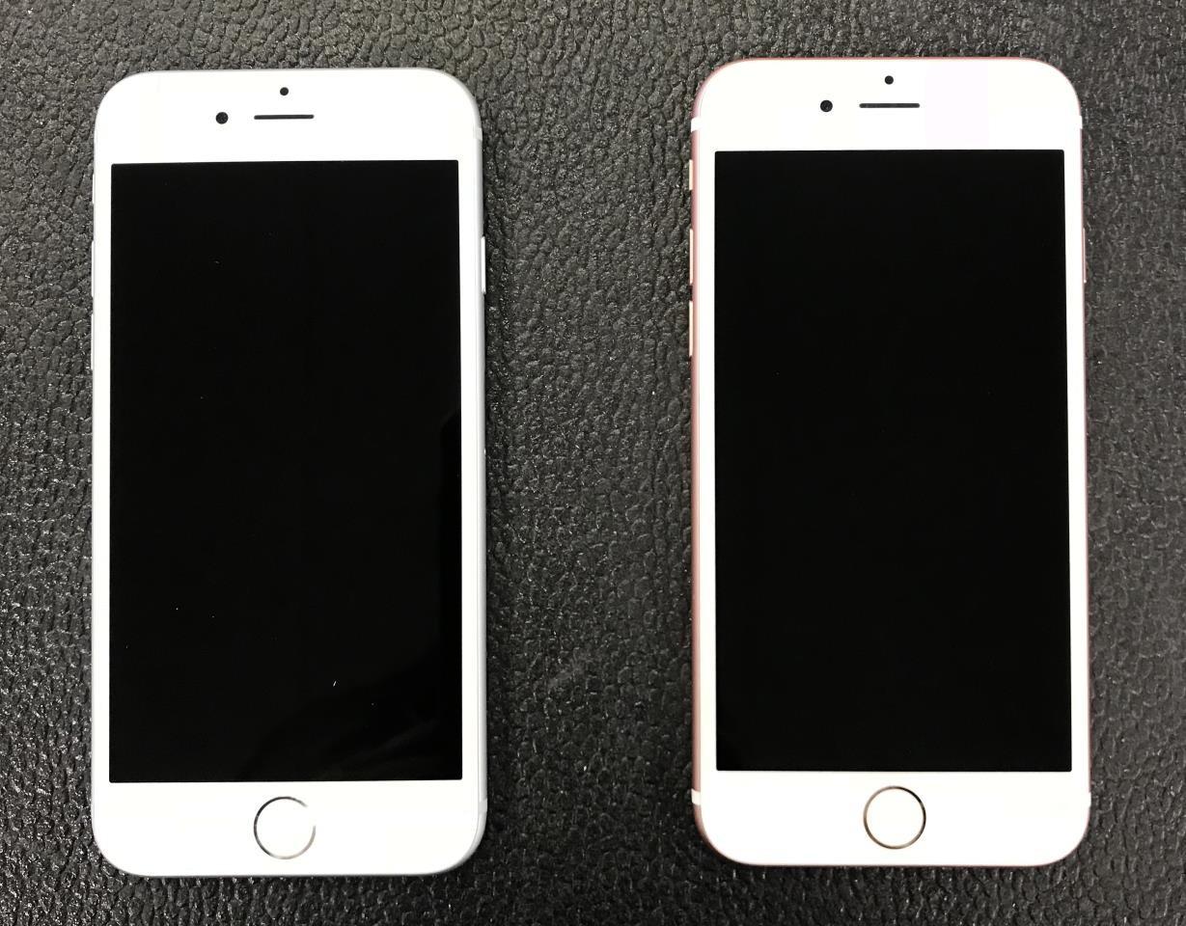

**A+**

* **100% SIM card unlocked.**
* **100% functional Touch ID.**
* **iCloud ID logged out**
* **Functional Wi-Fi, Camera, Bluetooth, microphone ect.**



***Cosmetic Descriptions:***

* **Device looks brand new, flawless, with no imperfections on the screen**

or housing.

* **NO scratches on screen.**
* **NO imperfections on housing.**
* **NO spots or light marks on LCD.**
* **Details are as shown in the following pictures:**

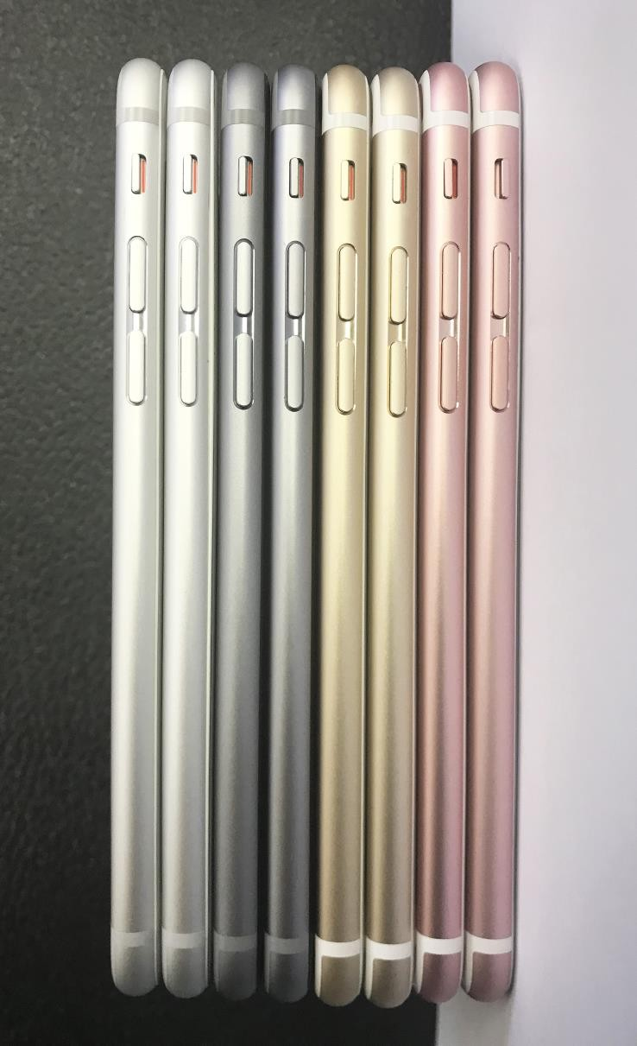

**A+**

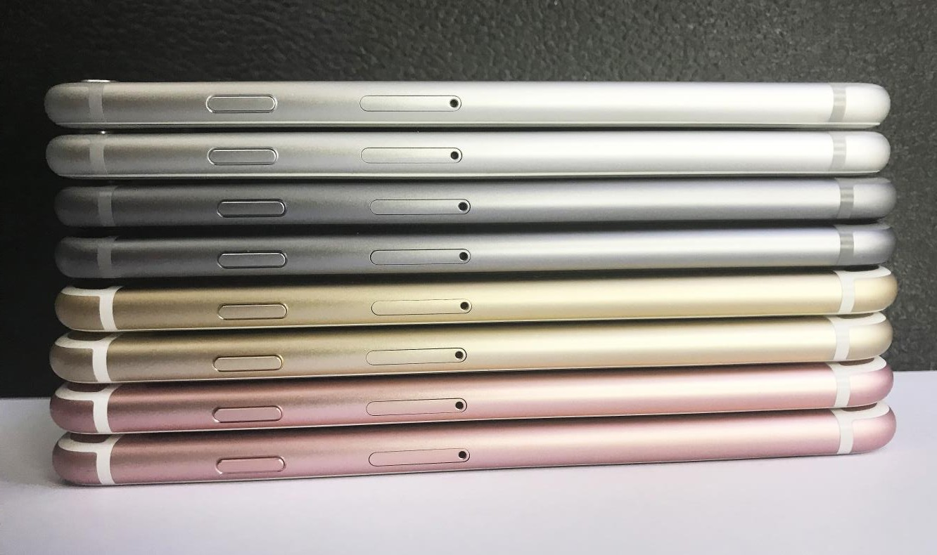

**A+**

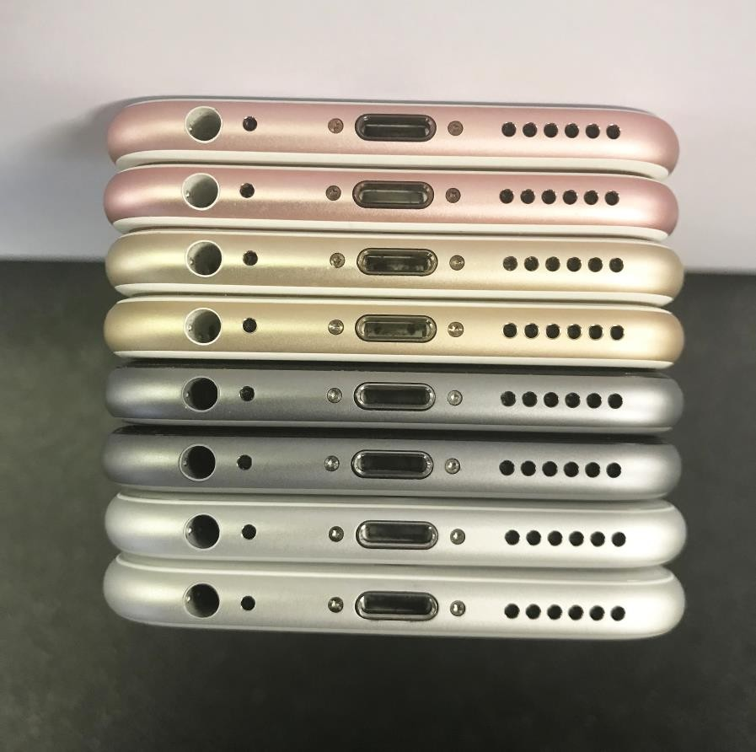

**A+**

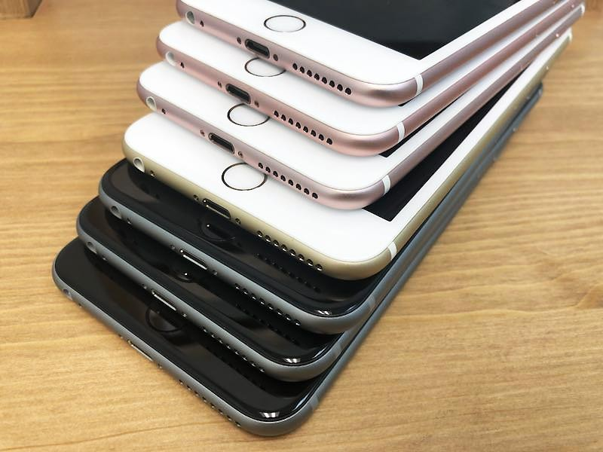

**A+**



**A+**

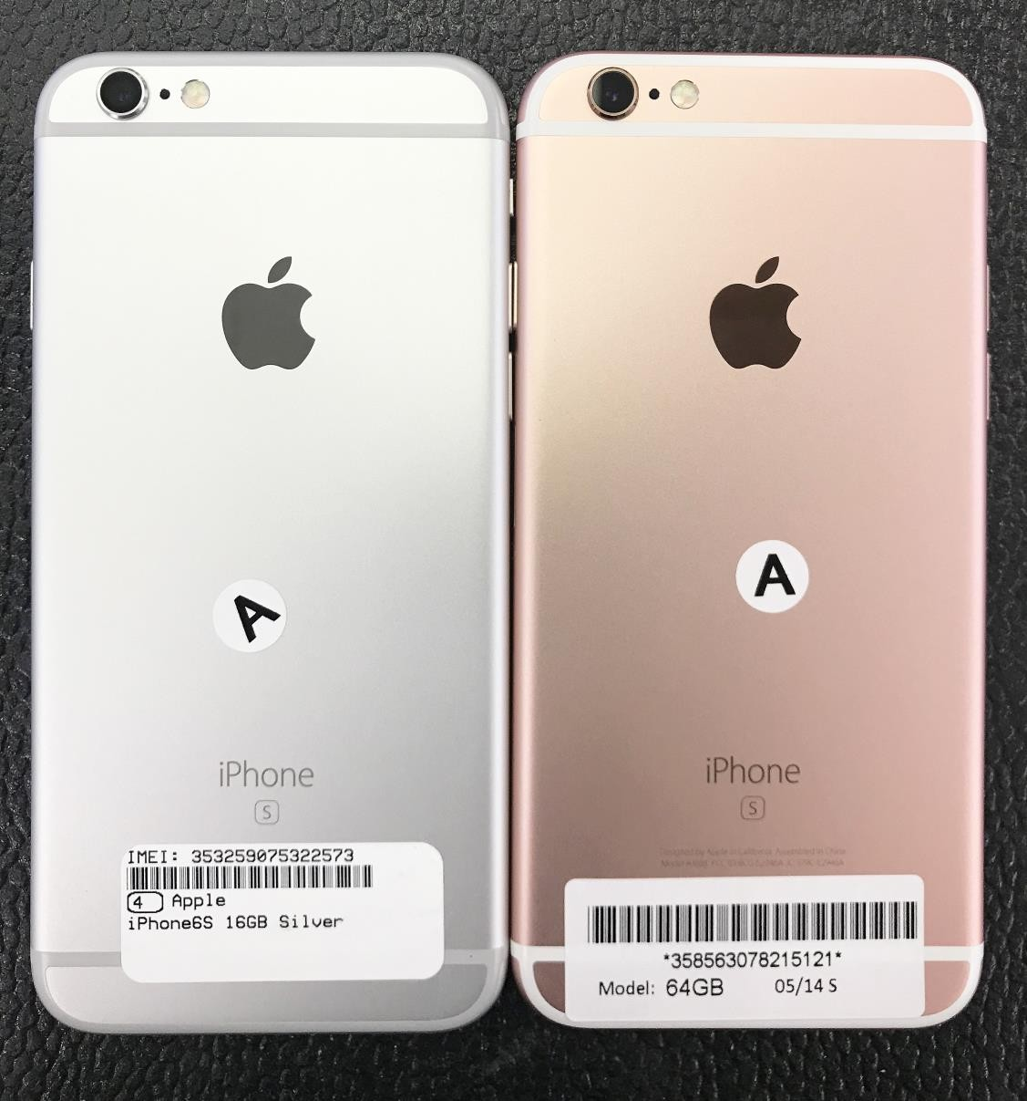

***All devices are fully tested and fully functional***

* **100% Power up**

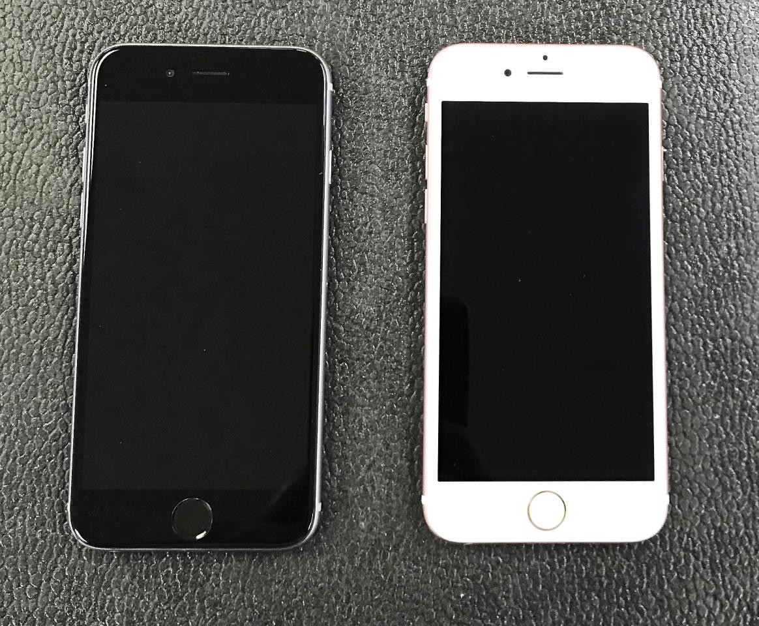

**A**

* **100% SIM card unlocked.**
* **100% functional Touch ID.**
* **iCloud ID logged out**
* **Functional Wi-Fi, Camera, Bluetooth, microphone ect.**



***Cosmetic Descriptions:***

* **Device is in excellent condition and may have very minimal**

imperfections on the screen and housing.

* **Only have few light scratches on screen or housing.**
* **NO dings or scuffs on housing.**
* **NO spots or light marks on LCD.**
* **Details are as shown in the following pictures:**

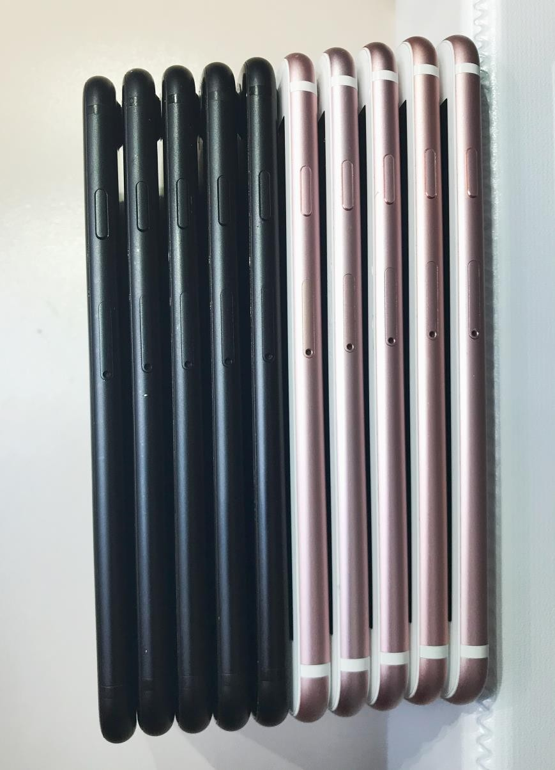

**A**

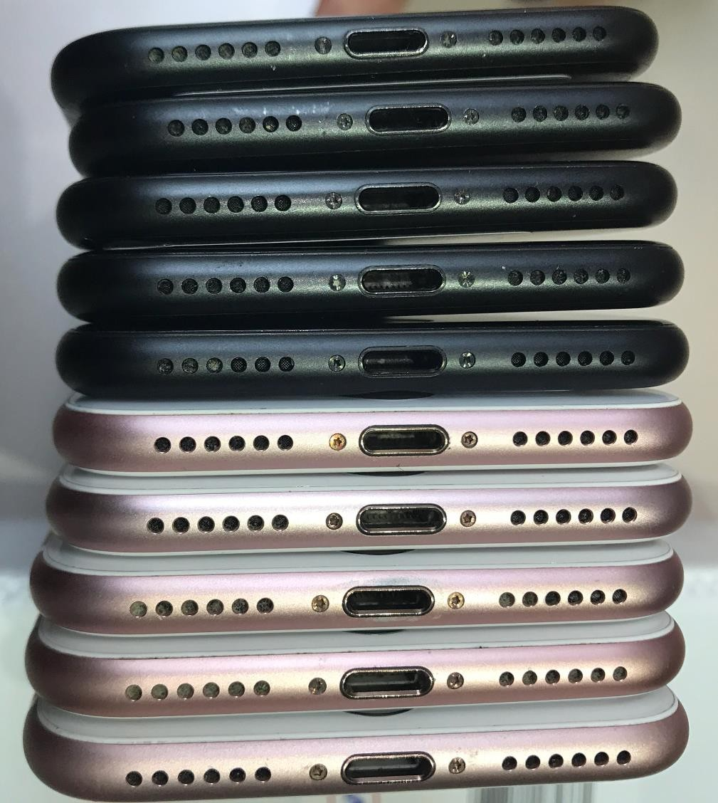

**A**



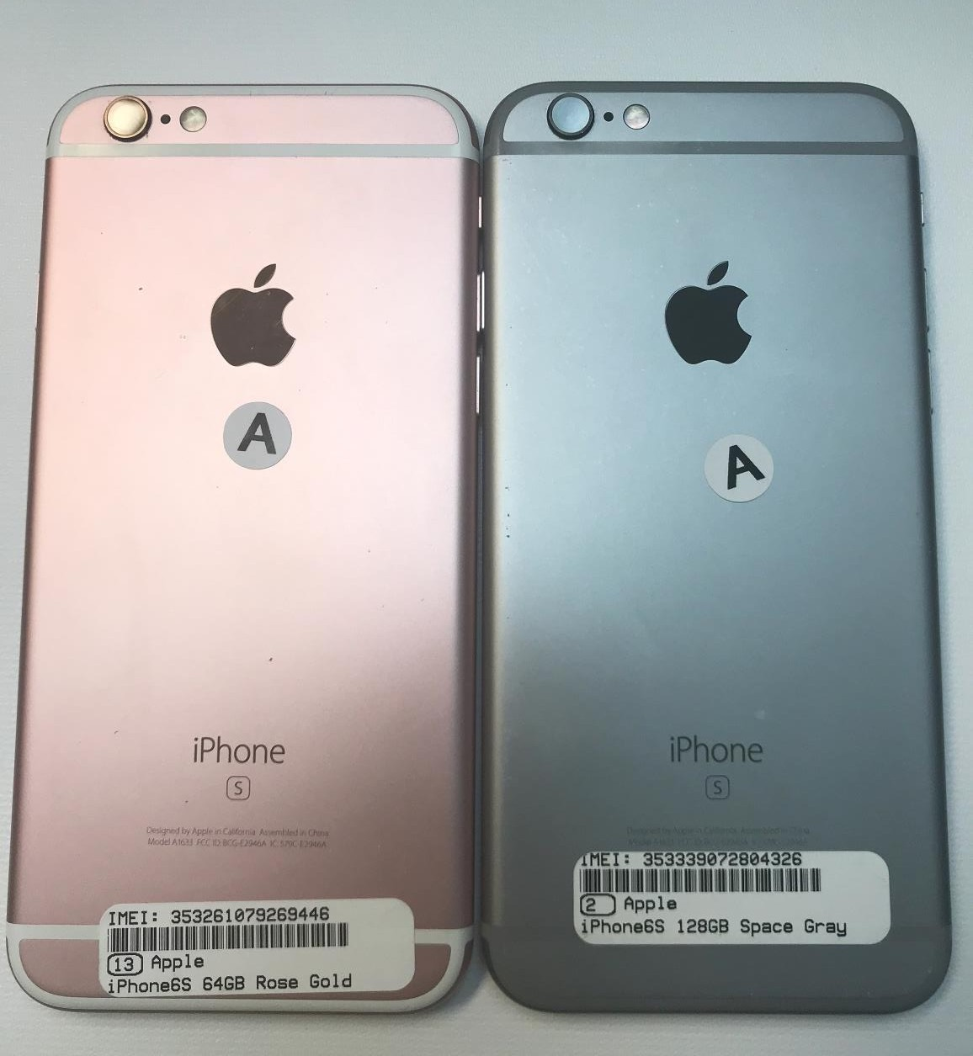

**Very few light scratches on**

**screen or housing.**





**A**



***All devices are fully tested and fully functional***

* **100% Power up**



**AB**

* **100% SIM card unlocked.**
* **100% functional Touch ID.**
* **iCloud ID logged out**
* **Functional Wi-Fi, Camera, Bluetooth, microphone**



***Cosmetic Descriptions:***

* **Device is in very good condition and may have some imperfections on the screen and housing.**
* **Only few light scratches on screen or housing.**
* **NO more than two light dings or scuffs on housing, no heavy dings or scuffs.**
* **NO spots or light marks on LCD.**
* **Details are as shown in the following pictures:**

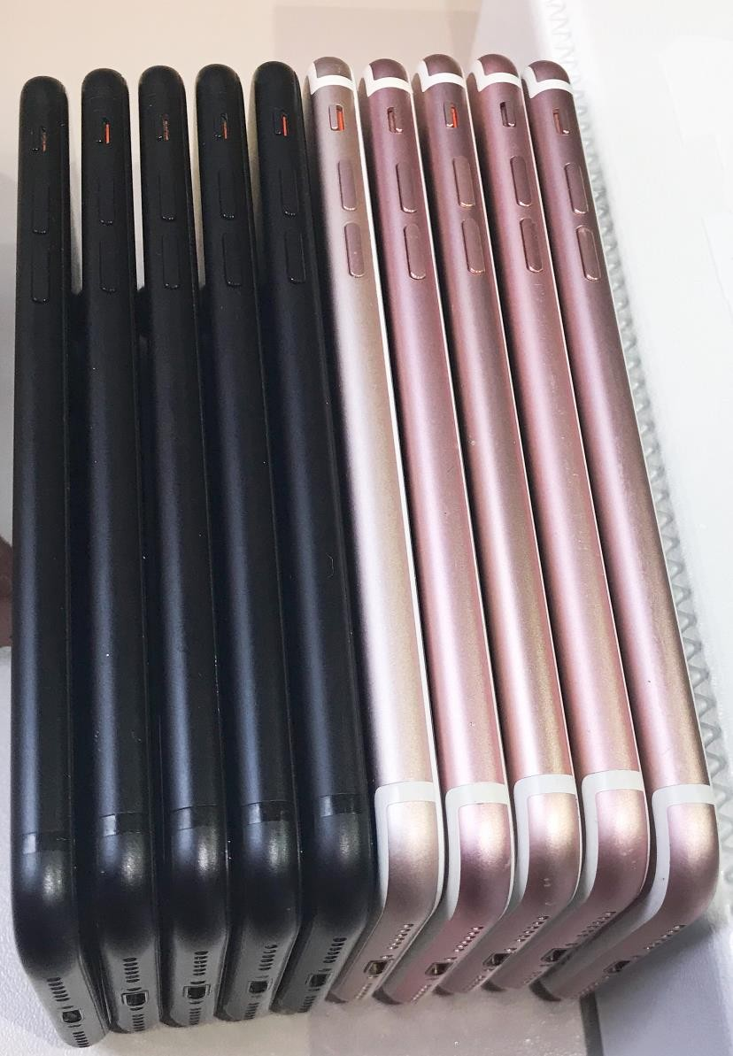

**AB**

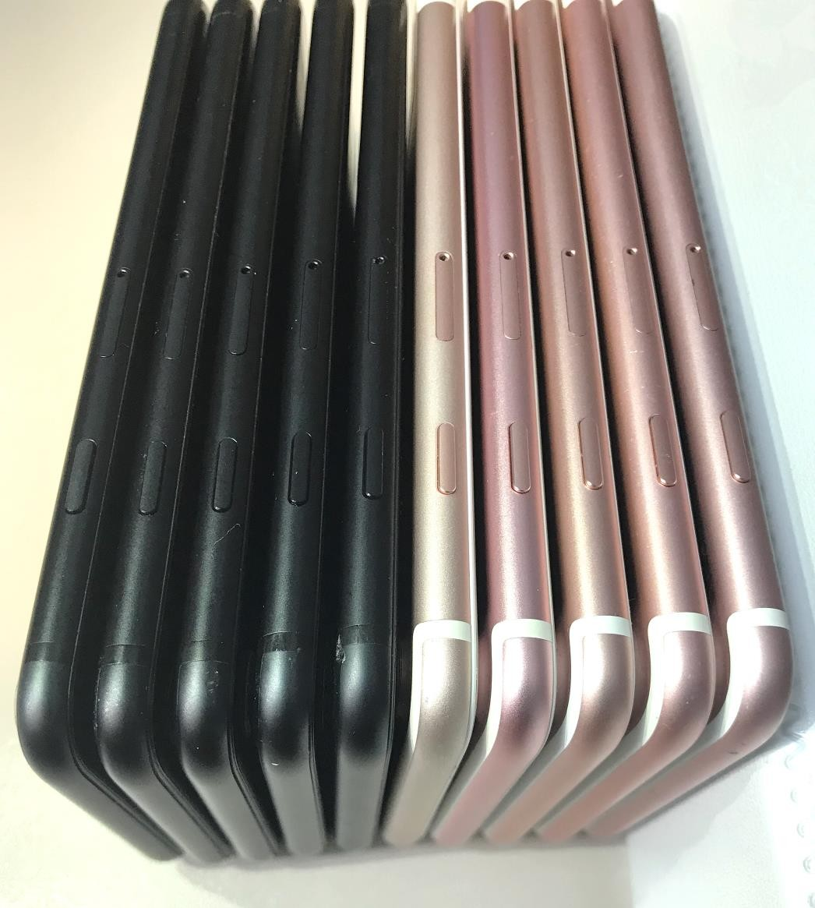

**AB**

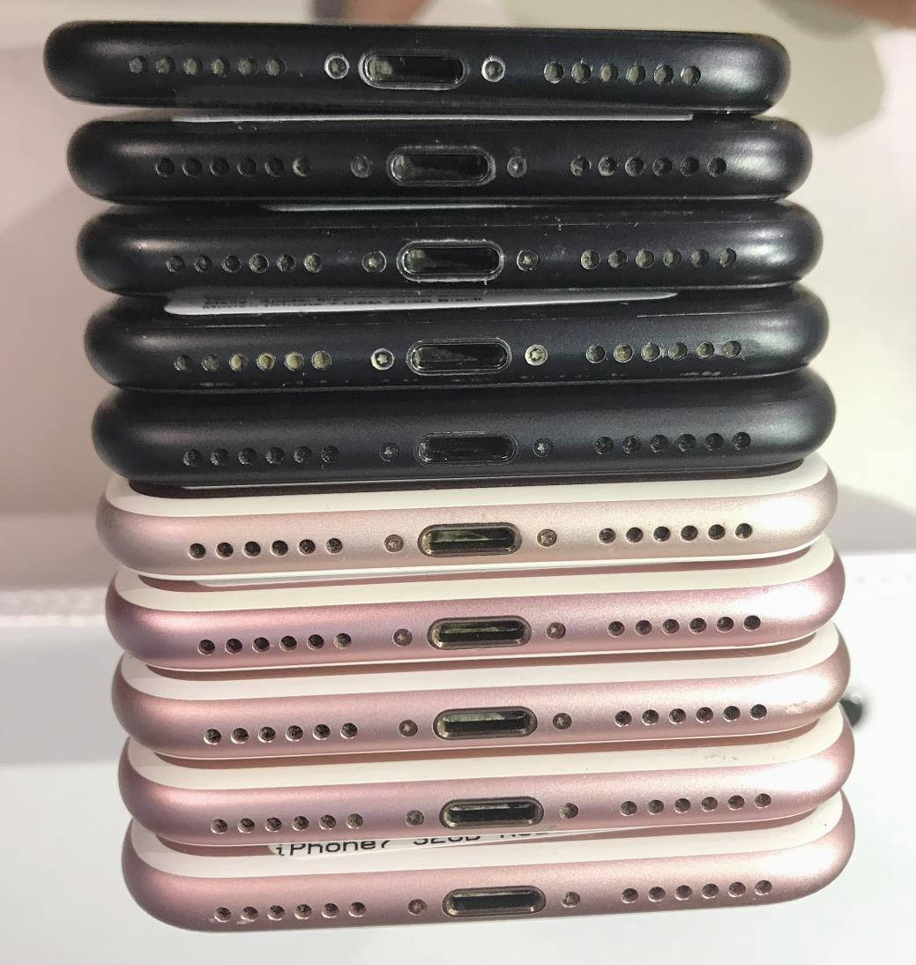

**AB**

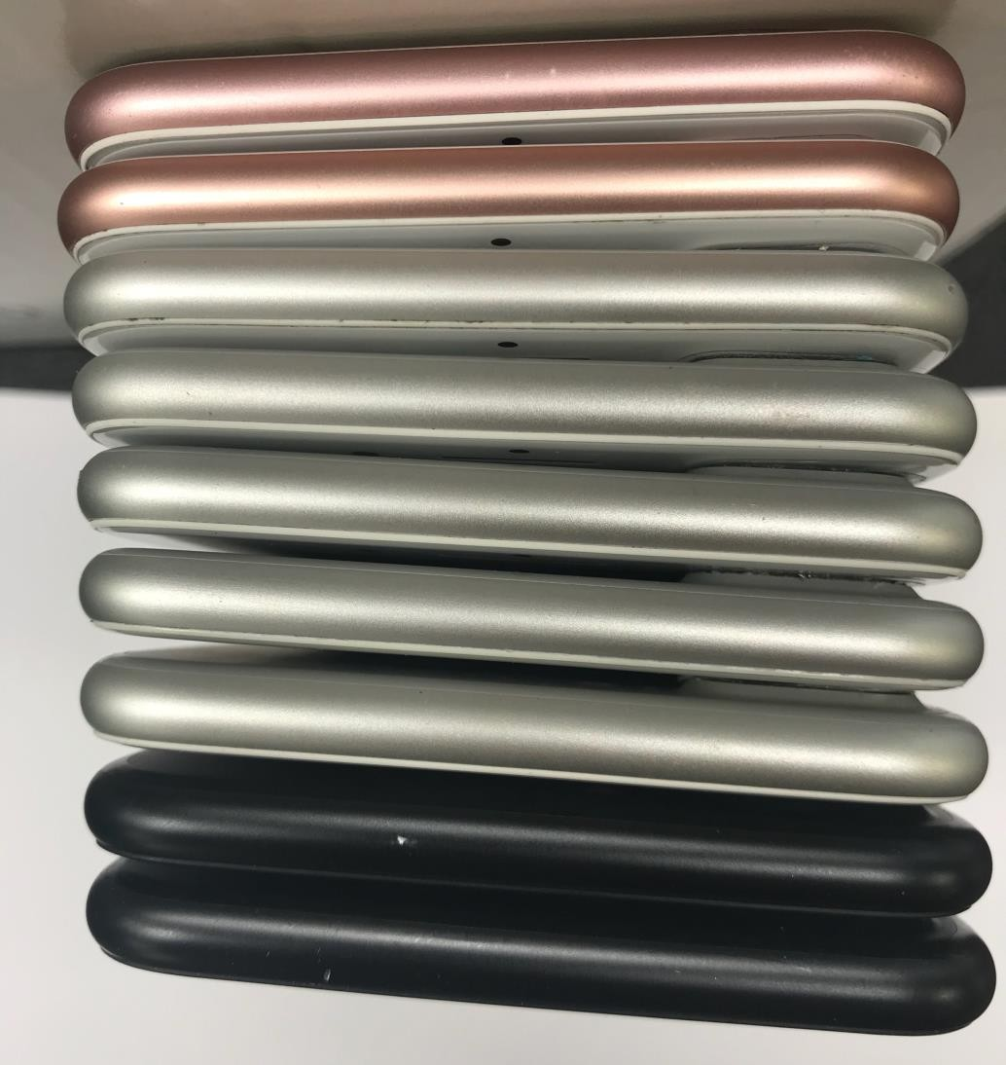

**AB**

**NO more than two light dings or scuffs on housing, no heavy dings or scuffs.**

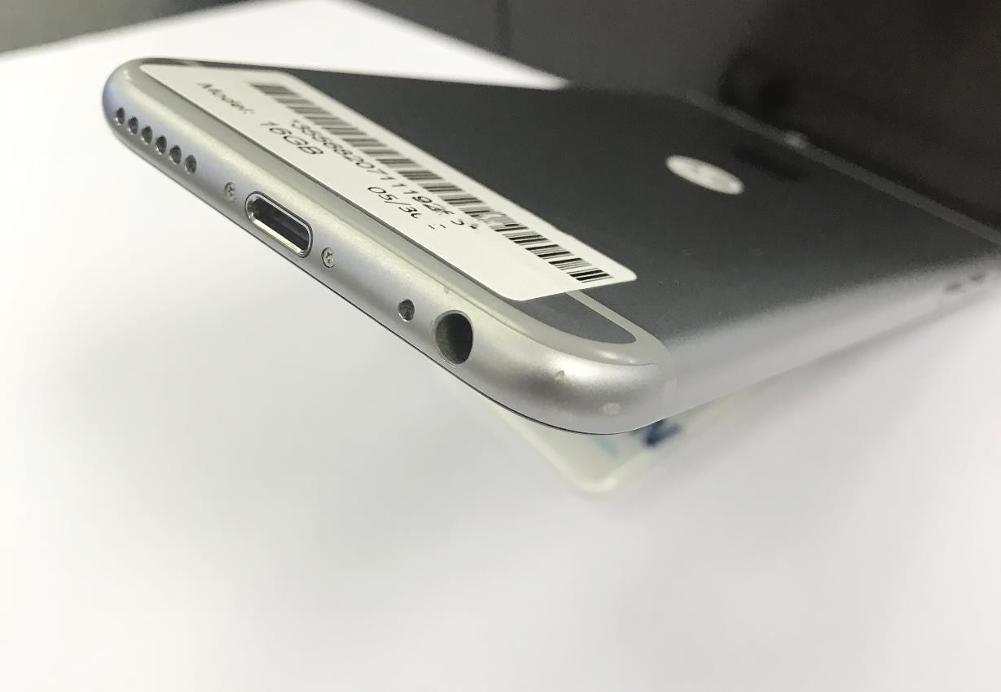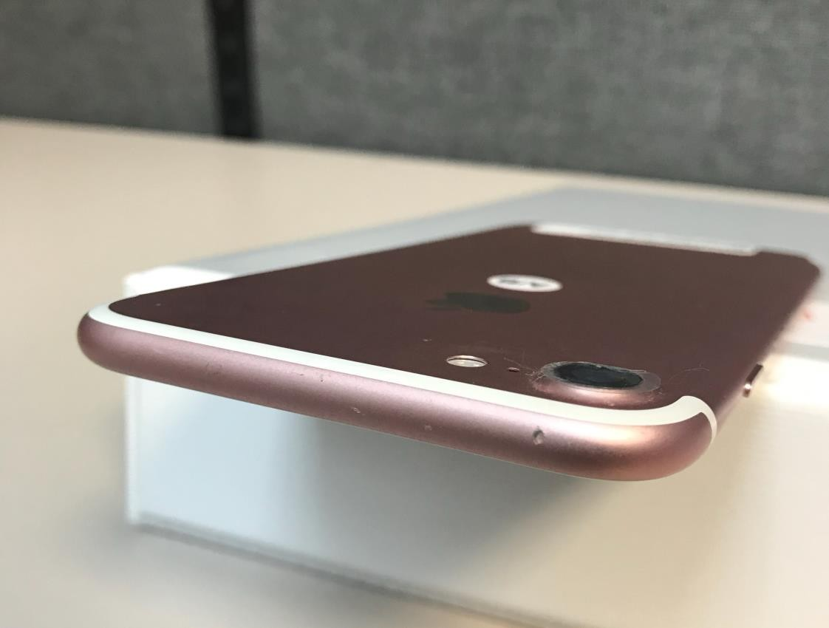

**AB**

**AB**

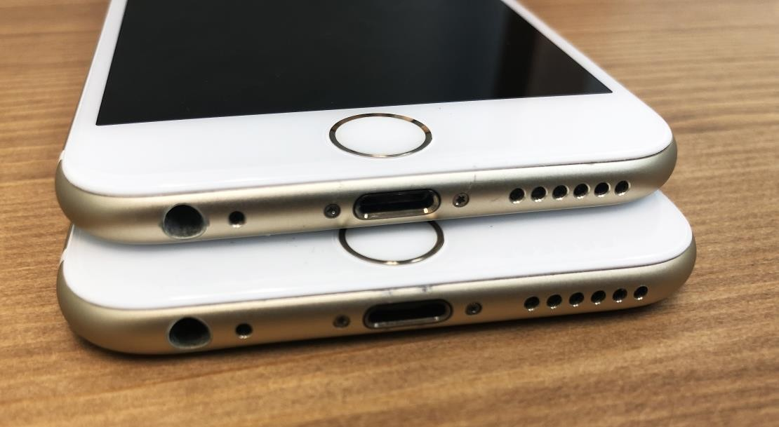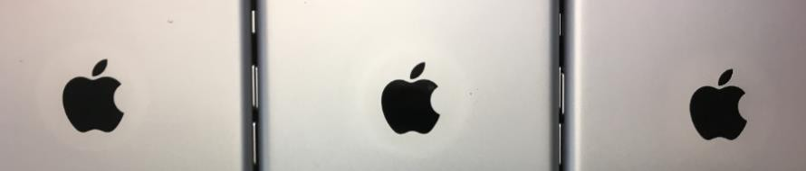

**Light visible marks or scratches near ports**

**Discoloration or Faded Color**

**AB near logos**

**AB**

**AB**

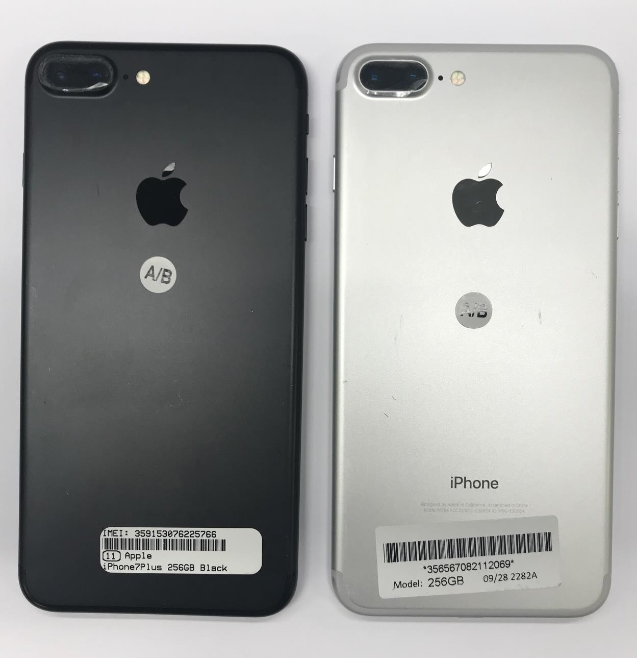

**Only few light scratches on screen or housing.**



***All devices are fully tested and fully functional***

* **100% Power up**

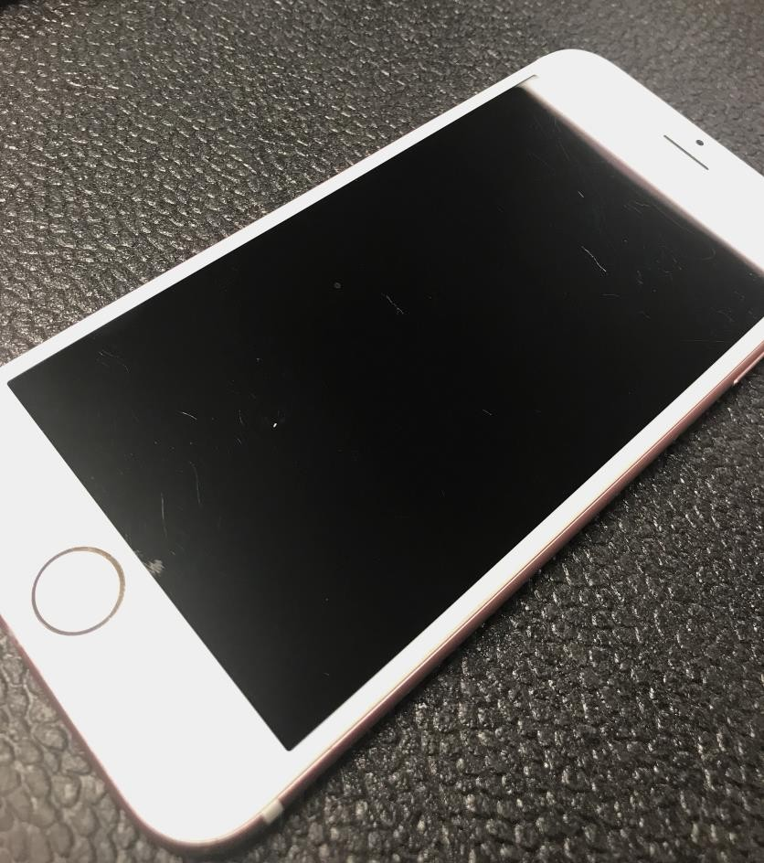

**B**

* **100% SIM card unlocked.**
* **100% functional Touch ID.**
* **iCloud ID logged out**
* **Functional Wi-Fi, Camera, Bluetooth, microphone**



***Cosmetic Descriptions:***

* **Device is in poor condition and with numerous heavy imperfections.**
* **May have numerous heavy scratches on screen or housing.**
* **May have numerous heavy dings or scuff on housing.**
* **No bends or abnormal frame damage.**
* **NO spots or light marks on LCD.**
* **Details are as shown in the following pictures:**

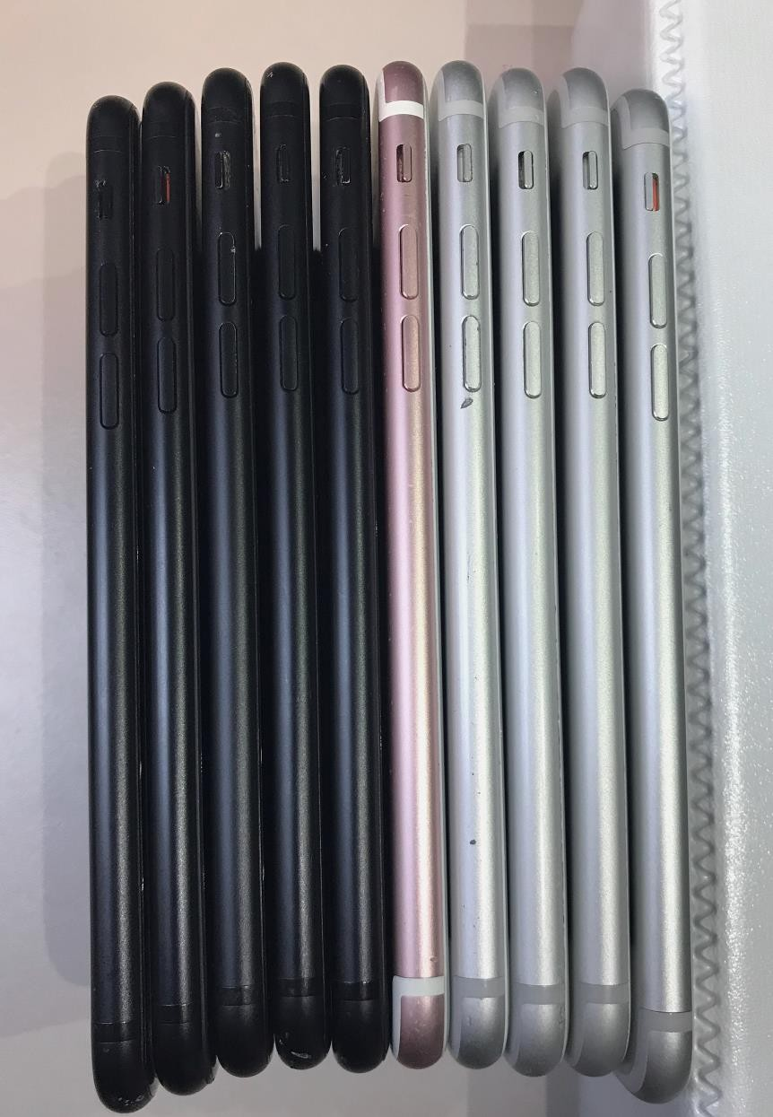

**B**

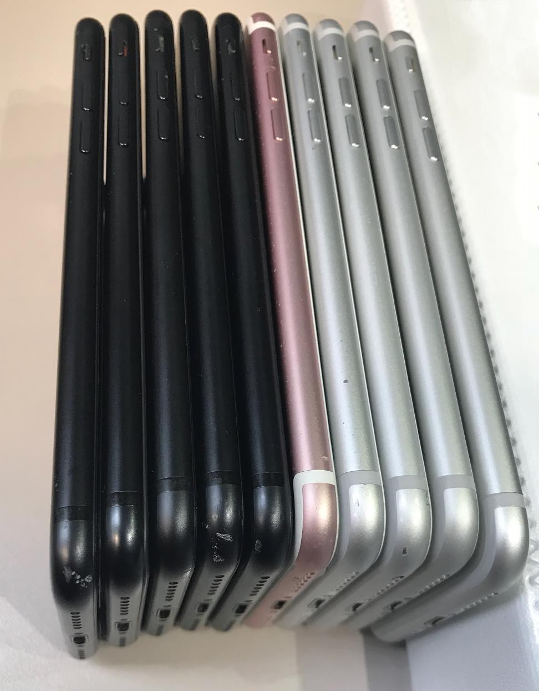

**B**

**May have numerous heavy scratches on screen or housing.**

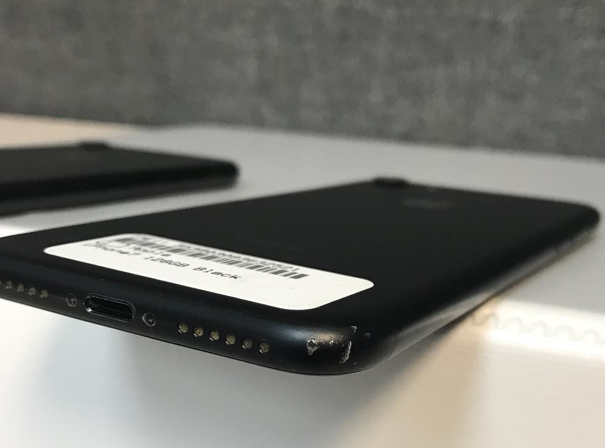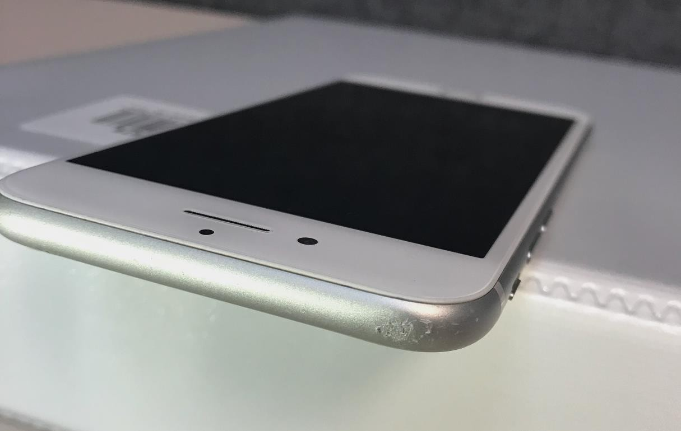

**B**

**B**

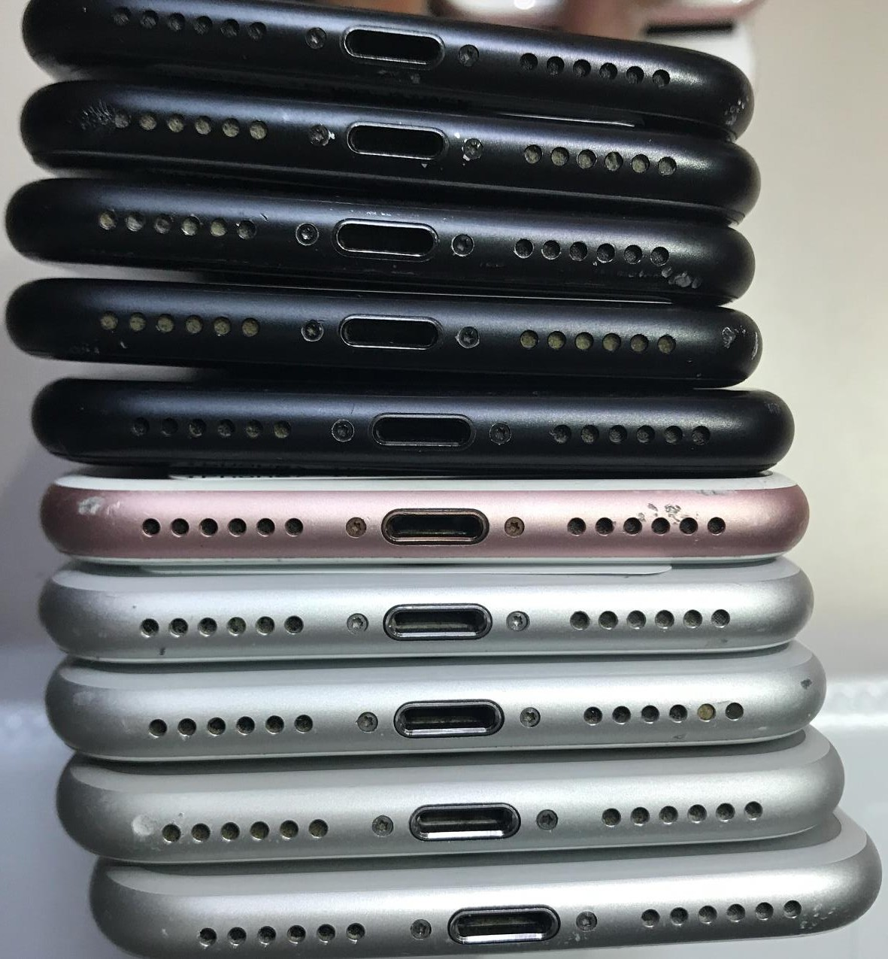

**B**

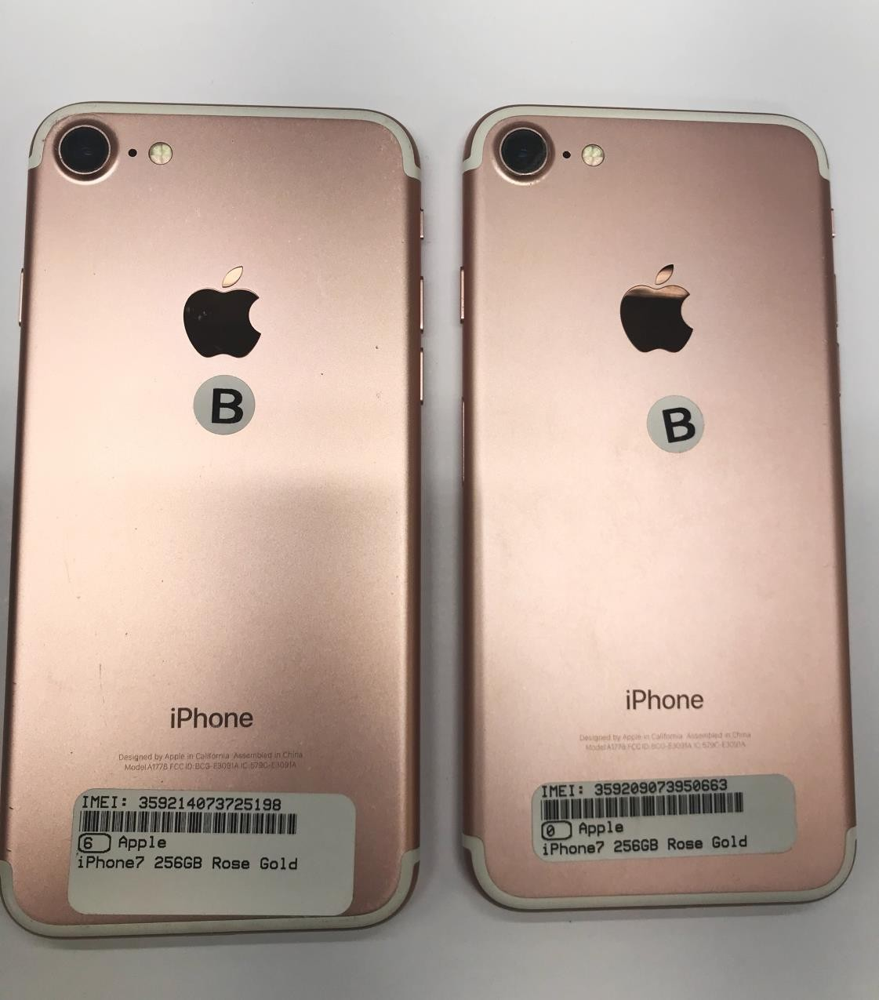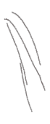

**B**

**May have numerous heavy**

**scratches on screen or housing.**